Part Number: PT420-00184-XX

PT420-00161-XX

PT420-00162-XX

PT420-00163-XX

Kit Contents
Item # | Quantity Reqd. | Description
1 | 1 | Key Glove (Set of 2)
Hardware Bag Contents
Item # | Quantity Reqd. | Description
1
Additional Items Required For Installation
Item # | Quantity Reqd. | Description
1
Conflicts
None
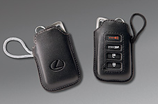
Recommended Tools
Personal & Vehicle Protection | Notes
None
Special Tools | Notes
None
Installation Tools | Notes
None
Special Chemicals | Notes
None
General Applicability
All
Recommended Sequence of Application
Item # | Accessory
1
2
3
*Mandatory
Vehicle Service Parts (may be required for reassembly)
Item # | Quantity Reqd. | Description
1
2
3
Legend
STOP: Damage to the vehicle may occur. Do not proceed until process has been complied with.
OPERATOR SAFETY: Use caution to avoid risk of injury.
CAUTION: A process that must be carefully observed in order to reduce the risk of damage to the accessory/vehicle and to ensure a quality installation.
TOOLS & EQUIPMENT: Used in Figures calls out the specific tools and equipment recommended for this process.
REVISION MARK: This mark highlights a change in installation with respect to previous issue.
SAFETY TORQUE: This mark indicates that torque is related to safety.

NOTE: Key fob shape varies by vehicle model.
Key glove shape, colors, and logo vary by part number. This procedure is applicable to various models and part numbers.

Care must be taken when installing this accessory to ensure damage does not occur to the vehicle. The installation of this accessory should follow approved guidelines to ensure a quality installation.

These guidelines can be found in the "Accessory Installation Practices" document.

This document covers such items as:-
- Vehicle Protection (use of covers and blankets, cleaning chemicals, etc.).
- Safety (eye protection, rechecking torque procedure, etc.).
- Vehicle Disassembly/Reassembly (panel removal, part storage, etc.).
- Electrical Component Disassembly/Reassembly (battery disconnection, connector removal, etc.).

Please see your Lexus dealer for a copy of this document.

Prepare the Key Fob.
  - Remove the key glove(s) from the packaging.
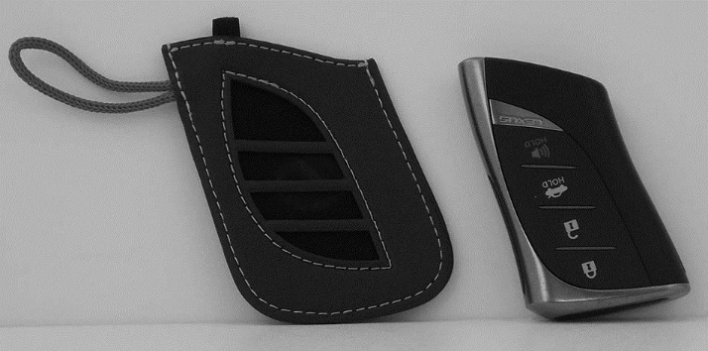
  - Orient the key glove with the cut-outs facing the installer (Fig. 1-1).
Fig. 1-1
  - Orient the key fob with the buttons facing the installer (Fig. 1-1).

Install the Key Fob into the Key Glove.
  - Pull the elastic tab (if present) to the side of the key glove (Fig 2-1).
Fig. 2-1

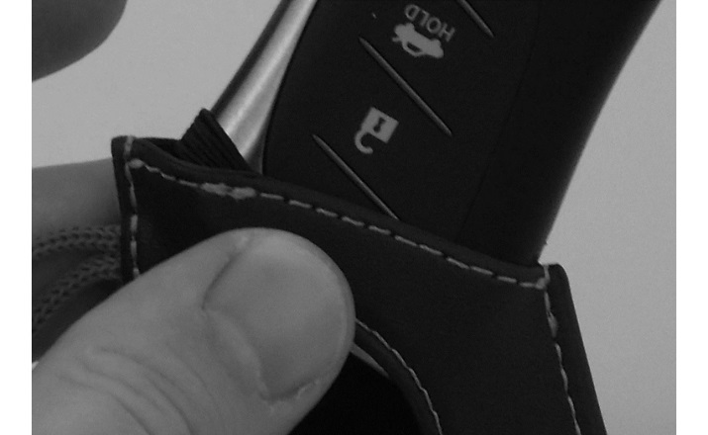
  - Insert the key fob into the glove, keeping the elastic tab off to the side (Fig 2-2).
Fig. 2-2

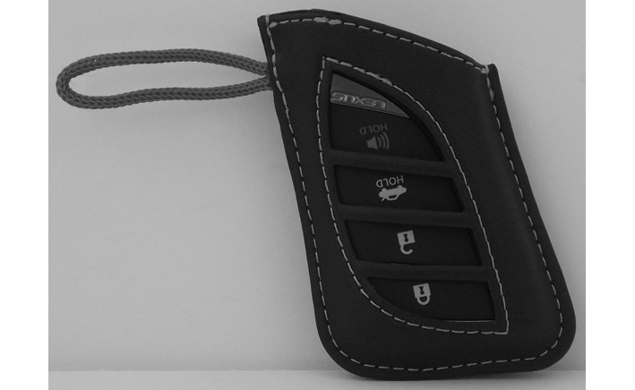
  - Push the key fob completely into the glove (Fig. 2-3).
Fig. 2-3

Complete the Installation.
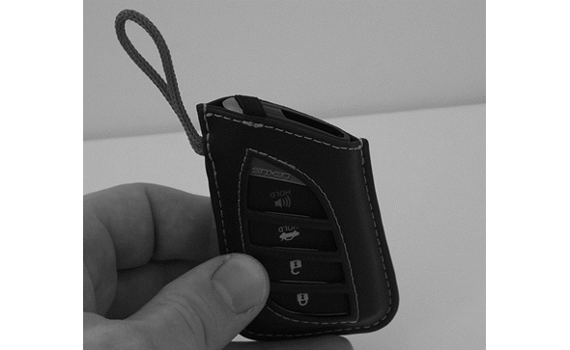
  - Release the elastic tab (if present) over the top of the key fob and align the cutouts (Fig. 3-1).
Fig. 3-1
Elastic tab

Accessory Function Checks
Verify parts: removed items have been discarded & replaced items are in place
Confirm proper alignment of key glove
cut-outs and fob buttons
Confirm elastic tab (if present) is secure over top of key fob.

Vehicle Function Checks

Misaligned key fob buttons

Elastic tab not over top of key fob

Vehicle Appearance Check
After accessory installation and removal of protective cover(s), perform a visual inspection.

Ensure no damage (including scuffs and scratches) was caused during the installation process.
(For PPO installations, refer to TMS Accessory Quality Shipping Standard.)

